[E134] Check valve

Unscrew the strain relief lock nut.

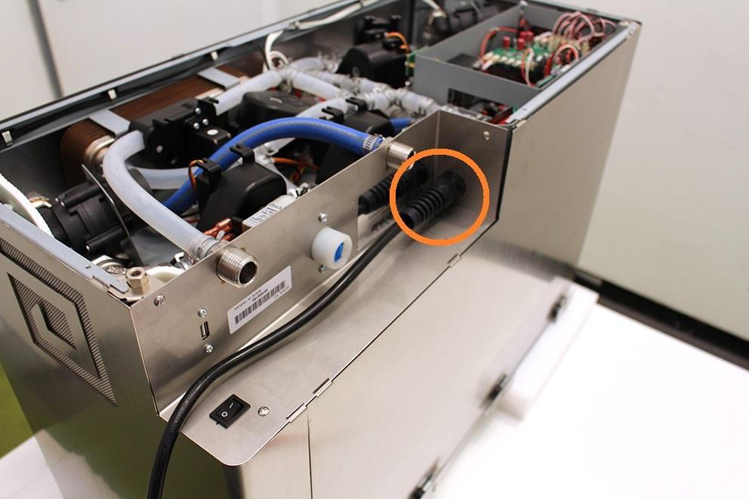

Remove the wort outlet hose clamp, pull off the wort outlet silicone tube and unscrew the indicated screws.

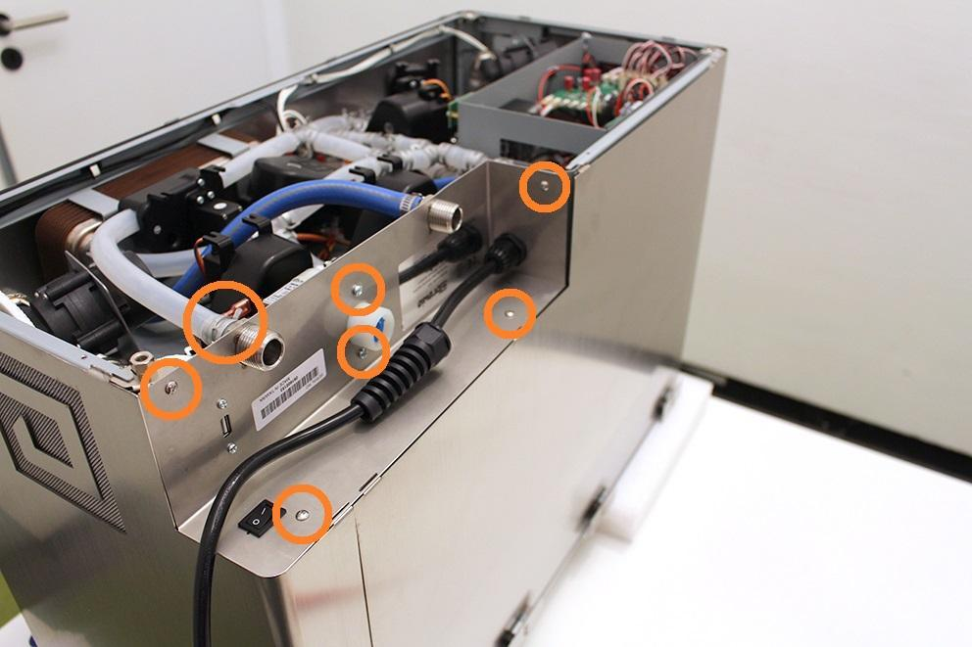

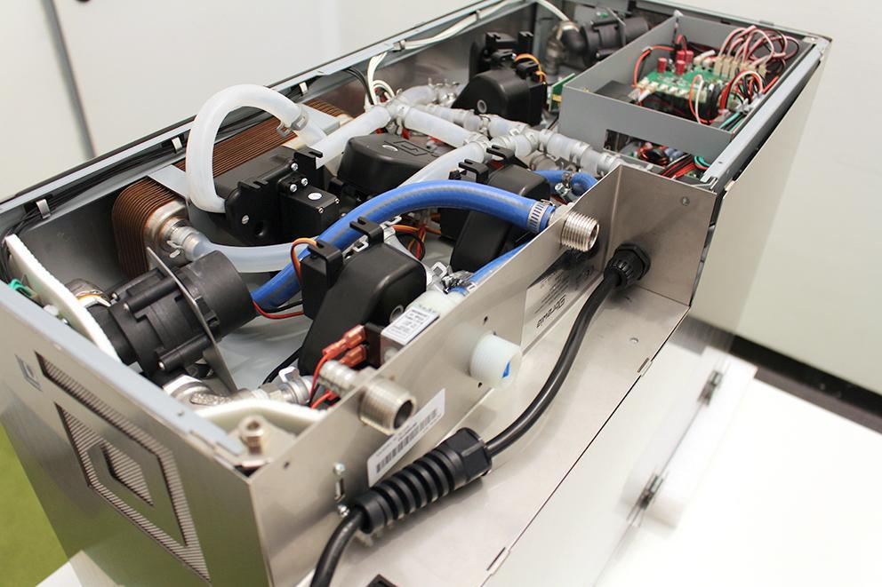

Remove the heat insulator.

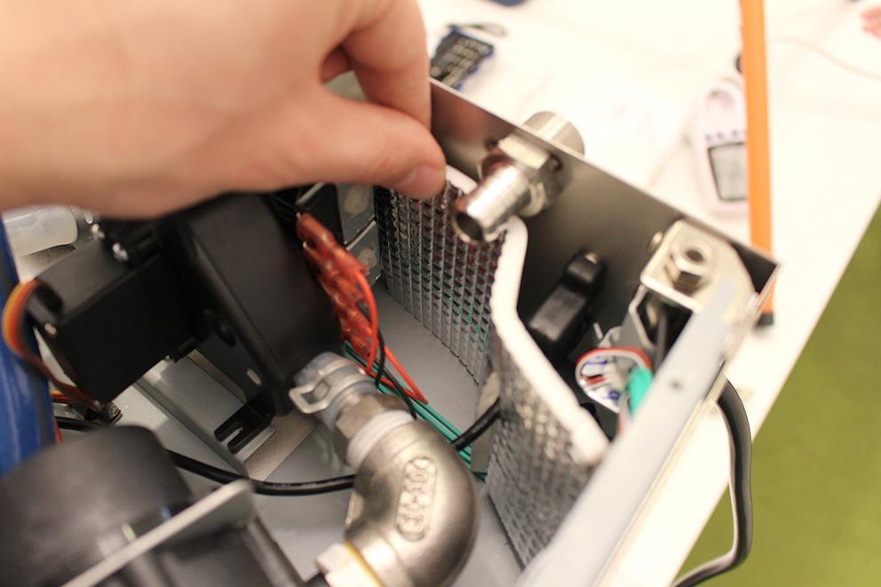

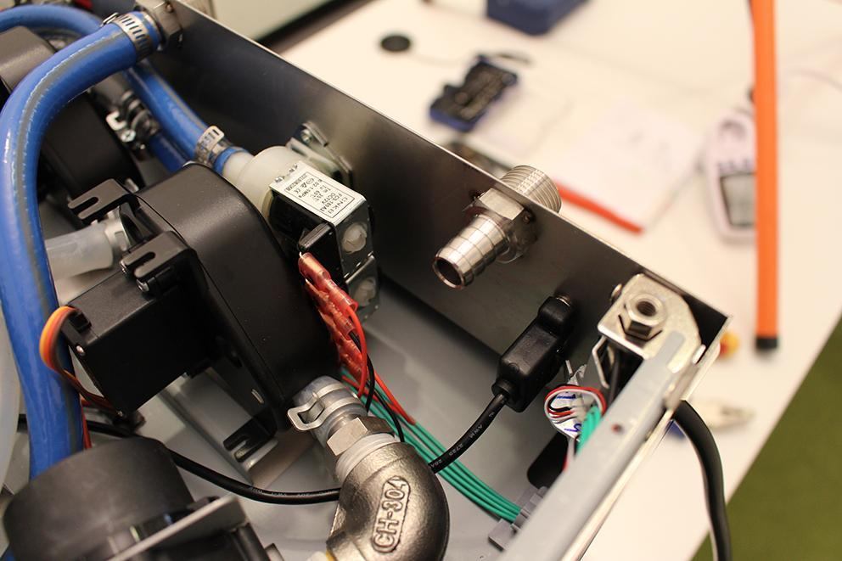

Remove the USB plug. Make sure that the washers don’t fall under the assembly plate. Use magnet for this step.

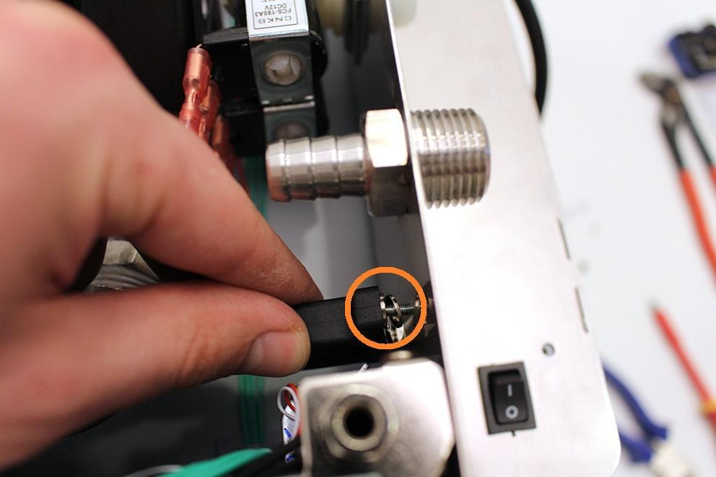

Loosen the indicated hose clamp and remove the high pressure hose from the fitting.

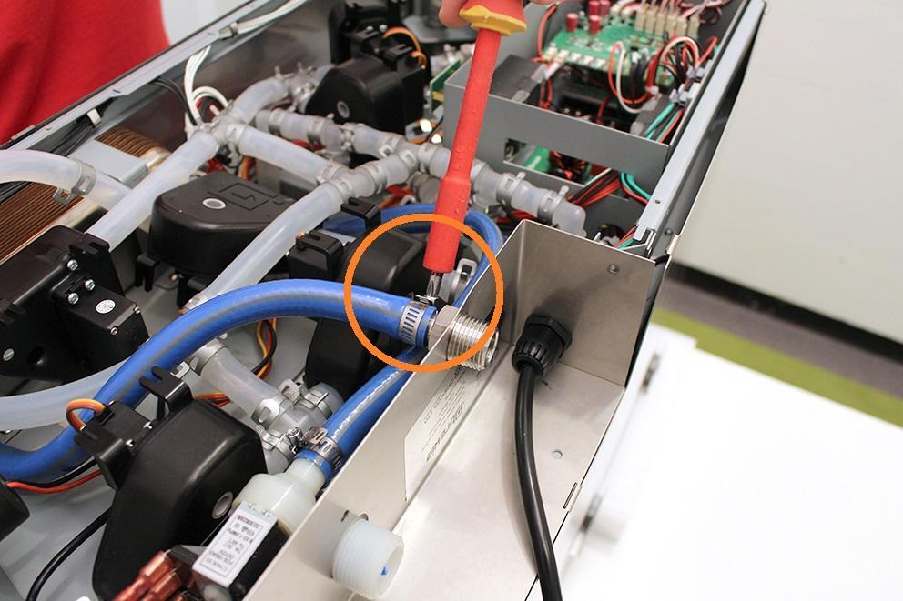

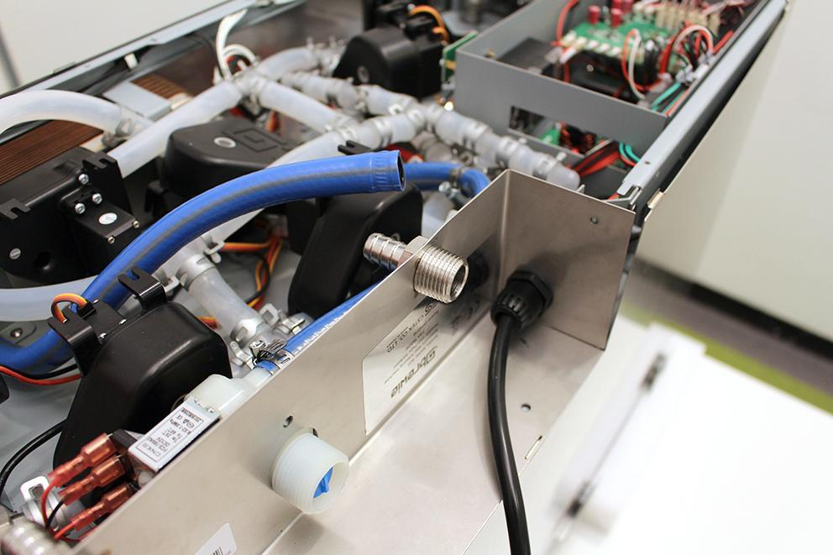

Pull up the sheetmetal part carefully and unplug the indicated plugs with a screwdriver.

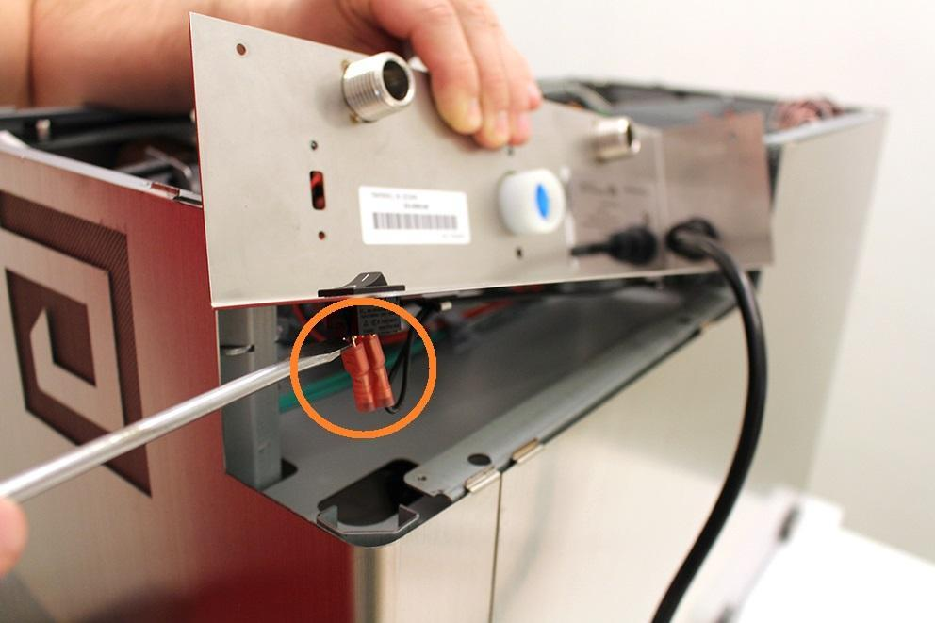

Remove the cables from the cable clips.

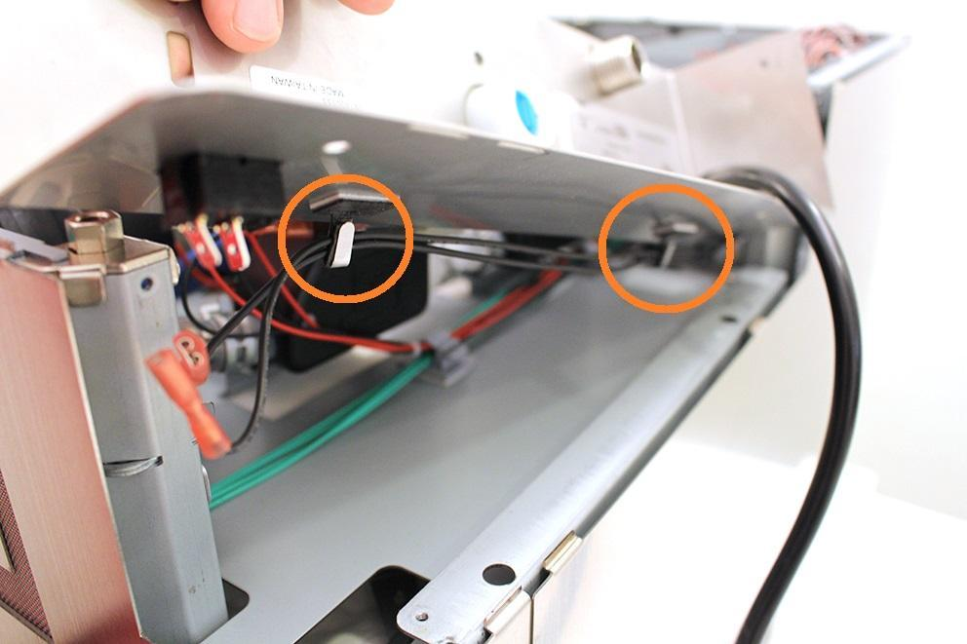

Pull off the high pressure valve from the sheetmetal. Pull off the sheetmetal on the power cable and put it on a safe place.

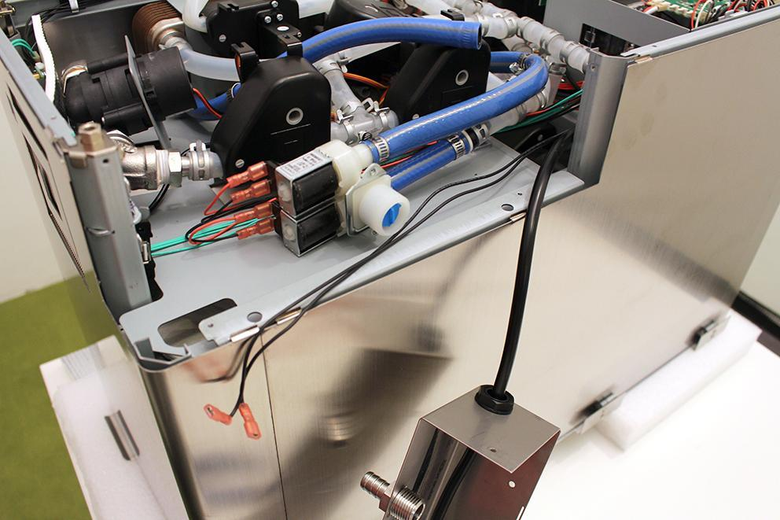

Grab the indicated hose clamp tightly with pliers and pull it off the valve. Loosen the clamp on the high-pressure (blue) hose and pull it off the valve.

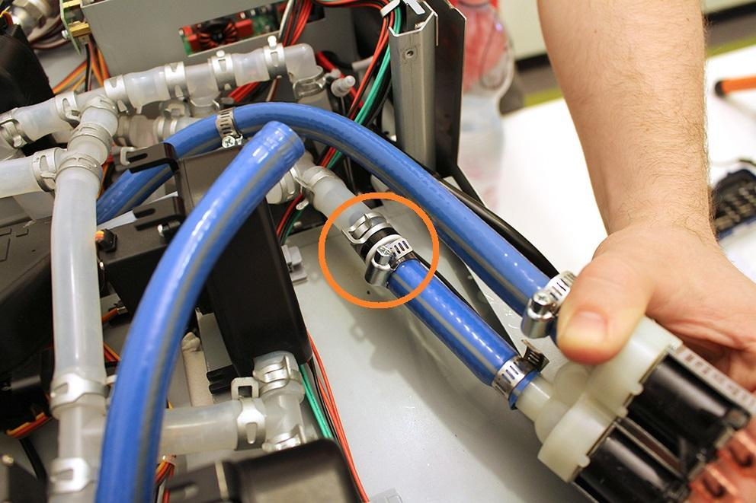

Pull the valve off the hoses and replace with the spare part. Reassembling consists of the same steps.

When reassembling, take care to put the drain hose’s clamp back in a position, in which it can’t prevent putting back the bottom.

